Bounded Region
# Source: AI Source: Provided by: [Data Path: Persons Table -> ID Column: 1, Name_En Column: Motasem Essam] -> From: [ChatGPT] on [7/25/2026]
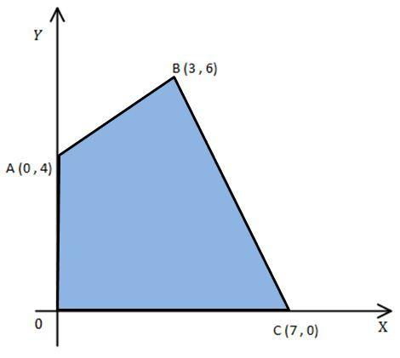
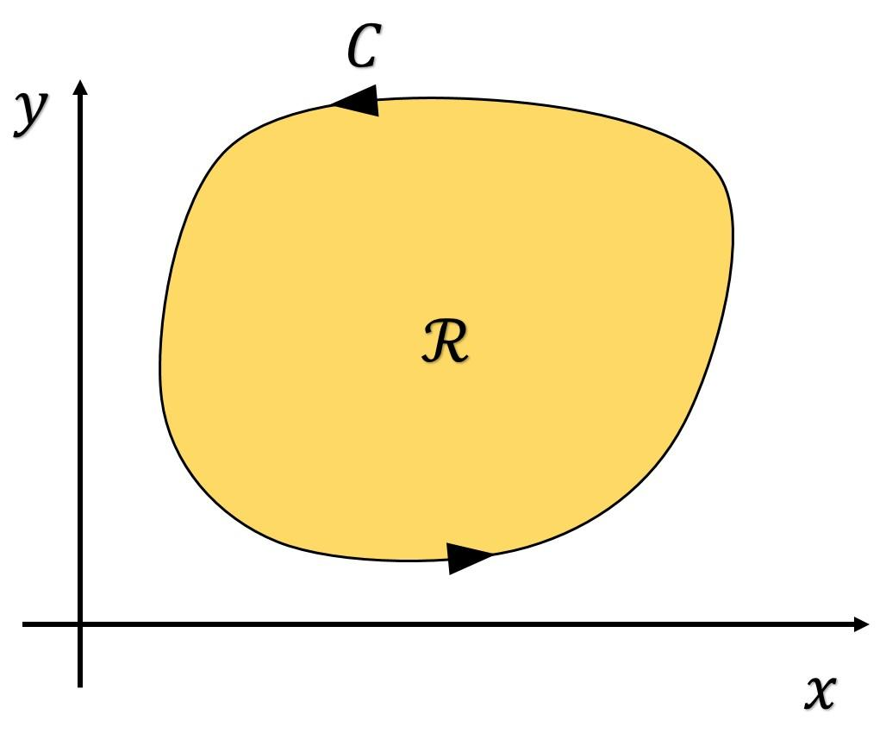
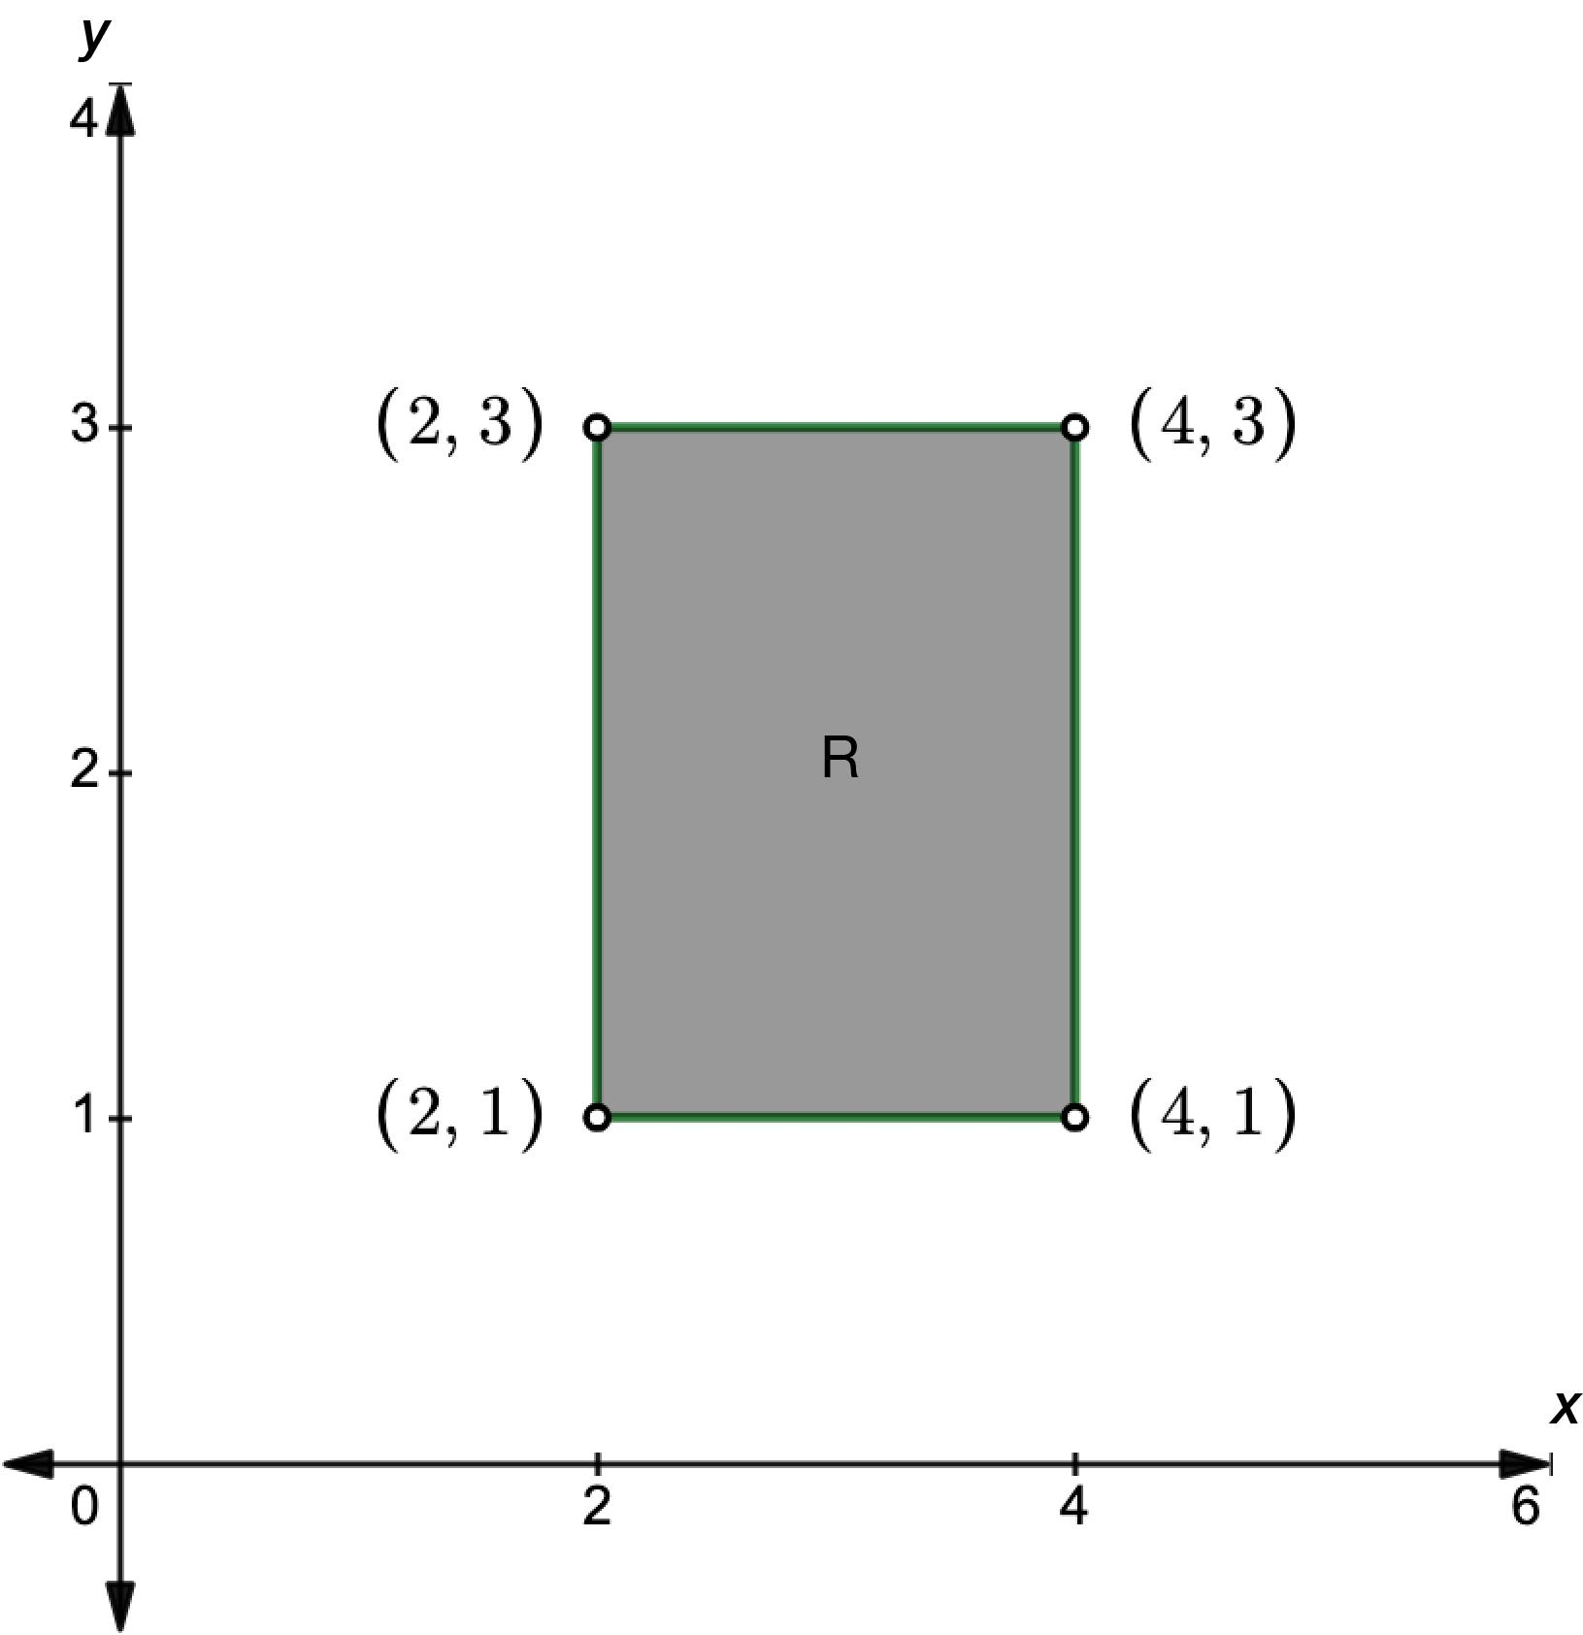
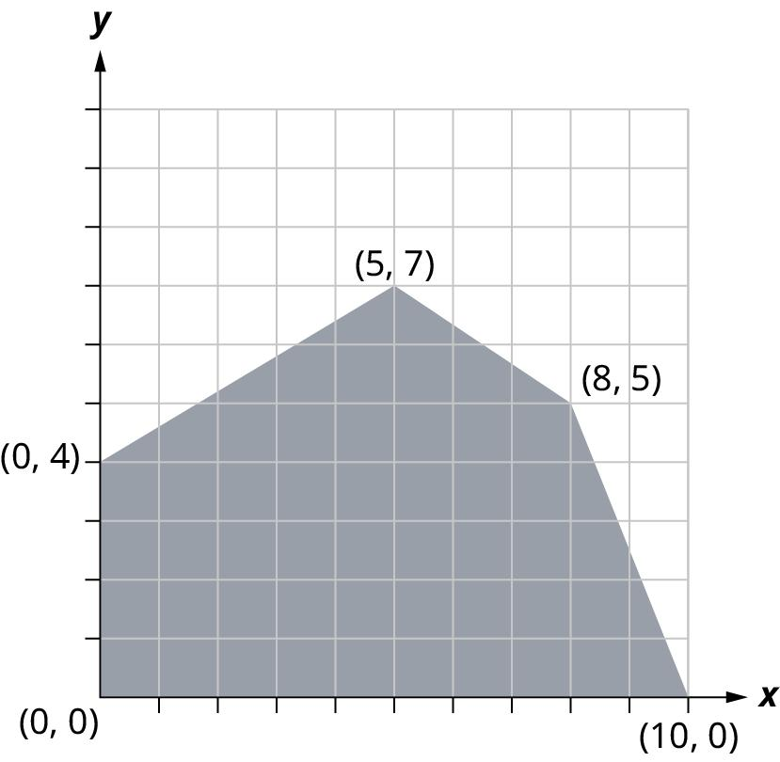
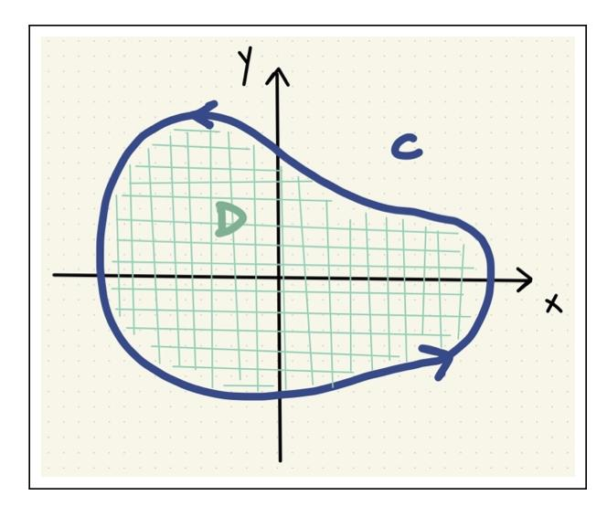
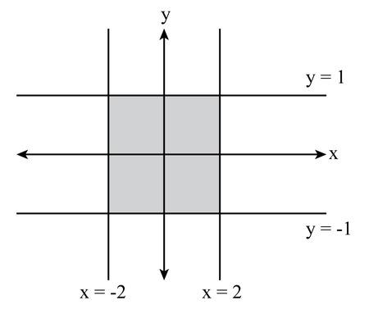

Definition
# Source: AI Source: Provided by: [Data Path: Persons Table -> ID Column: 1, Name_En Column: Motasem Essam] -> From: [ChatGPT] on [7/25/2026]
A Bounded Region is a region of the plane that is completely enclosed by one or more boundaries. Every point in the region lies within a finite distance from the boundary, meaning the region does not extend infinitely in any direction.
A bounded region always has:
- A closed boundary.
- A finite area.

Characteristics
# Source: AI Source: Provided by: [Data Path: Persons Table -> ID Column: 1, Name_En Column: Motasem Essam] -> From: [ChatGPT] on [7/25/2026]
A bounded region:
- Is completely enclosed by a boundary.
- Has a finite area.
- Does not extend infinitely.
- Has an interior, a boundary, and an exterior.
- Can be regular or irregular in shape.
- Contains infinitely many points within its finite extent.

Illustration

Bounded Rectangular Region
# Source: AI Source: Provided by: [Data Path: Persons Table -> ID Column: 1, Name_En Column: Motasem Essam] -> From: [ChatGPT] on [7/25/2026]
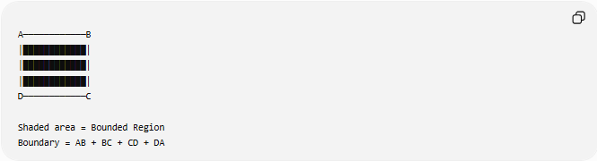
A────────────B
│████████████│
│████████████│
│████████████│
D────────────C

Shaded area = Bounded Region
Boundary = AB + BC + CD + DA
The shaded area is completely enclosed by the rectangle's boundary.

Bounded Circular Region
# Source: AI Source: Provided by: [Data Path: Persons Table -> ID Column: 1, Name_En Column: Motasem Essam] -> From: [ChatGPT] on [7/25/2026]
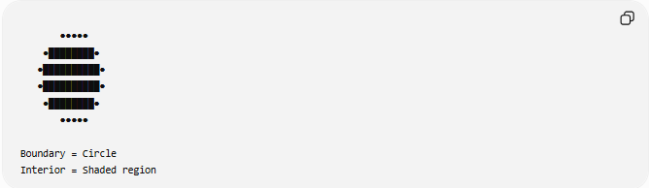
●●●●●
●████████●
●██████████●
●██████████●
●████████●
●●●●●

Boundary = Circle
Interior = Shaded region
The shaded region inside the circle is a bounded region.

Mathematical Representation
# Source: AI Source: Provided by: [Data Path: Persons Table -> ID Column: 1, Name_En Column: Motasem Essam] -> From: [ChatGPT] on [7/25/2026]
Suppose a region is enclosed by a boundary:
$$∂R$$
The bounded region consists of:
$$R$$
together with its interior, and sometimes its boundary depending on the definition.
Example:
Interior of a circle:
$$x^{2}+y^{2}<r^{2}$$
Closed circular region:
$$x^{2}+y^{2}≤r^{2}$$
Both describe bounded regions.

Examples
# Source: AI Source: Provided by: [Data Path: Persons Table -> ID Column: 1, Name_En Column: Motasem Essam] -> From: [ChatGPT] on [7/25/2026]
Example 1 – Triangle
A triangle encloses one bounded region.
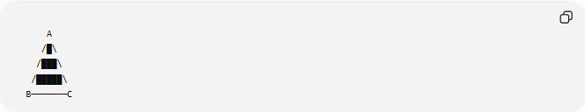
A
/█\
/███\
/█████\
B───────C

Example 2 – Rectangle
A rectangle encloses a finite region.
Area:
$$A=l×w$$

Example 3 – Circle
A circle encloses a bounded region.
Area:
$$A=πr^{2}$$

Area of a Bounded Region
# Source: AI Source: Provided by: [Data Path: Persons Table -> ID Column: 1, Name_En Column: Motasem Essam] -> From: [ChatGPT] on [7/25/2026]
Every bounded region has a finite area.
Examples:
Rectangle:
$$A=lw$$
Triangle:
$$A=\frac{12}{b}h$$
Circle:
$$A=πr^{2}$$
Trapezoid:
$$A=\frac{\left(a+b\right)h}{2}$$

Boundary of a Bounded Region
# Source: AI Source: Provided by: [Data Path: Persons Table -> ID Column: 1, Name_En Column: Motasem Essam] -> From: [ChatGPT] on [7/25/2026]
Every bounded region has a closed boundary.
Examples:
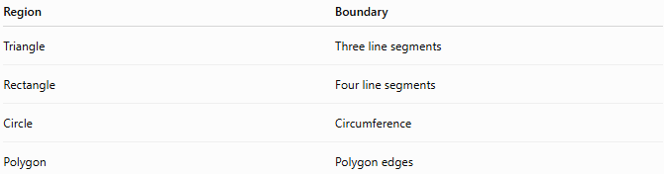
Region | Boundary
Triangle | Three line segments
Rectangle | Four line segments
Circle | Circumference
Polygon | Polygon edges

Real-World Examples
# Source: AI Source: Provided by: [Data Path: Persons Table -> ID Column: 1, Name_En Column: Motasem Essam] -> From: [ChatGPT] on [7/25/2026]
Bounded regions include:
- Rooms.
- Gardens enclosed by fences.
- Swimming pools.
- Lakes.
- Parks.
- Sports fields.
- Land plots.
- Building floors.
- Parking spaces.

Applications
# Source: AI Source: Provided by: [Data Path: Persons Table -> ID Column: 1, Name_En Column: Motasem Essam] -> From: [ChatGPT] on [7/25/2026]
Bounded regions are used in:
- Plane Geometry
- Coordinate Geometry
- Analytic Geometry
- Topology
- Engineering
- Architecture
- Surveying
- CAD (Computer-Aided Design)
- GIS (Geographic Information Systems)
- Computer Graphics

Advantages
# Source: AI Source: Provided by: [Data Path: Persons Table -> ID Column: 1, Name_En Column: Motasem Essam] -> From: [ChatGPT] on [7/25/2026]
Studying bounded regions helps to:
- Compute area.
- Define enclosed spaces.
- Model real-world objects.
- Solve optimization problems.
- Analyze geometric figures.

Limitations
# Source: AI Source: Provided by: [Data Path: Persons Table -> ID Column: 1, Name_En Column: Motasem Essam] -> From: [ChatGPT] on [7/25/2026]
A bounded region:
- Must have a closed boundary.
- Cannot extend infinitely.
- May become difficult to analyze if the boundary is highly irregular.

Comparison with Other Region Types
# Source: AI Source: Provided by: [Data Path: Persons Table -> ID Column: 1, Name_En Column: Motasem Essam] -> From: [ChatGPT] on [7/25/2026]
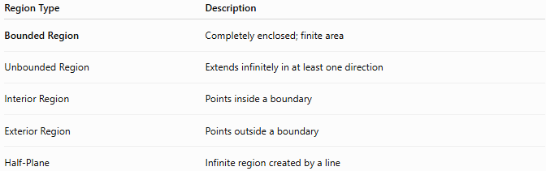
Region Type | Description
Bounded Region | Completely enclosed; finite area
Unbounded Region | Extends infinitely in at least one direction
Interior Region | Points inside a boundary
Exterior Region | Points outside a boundary
Half-Plane | Infinite region created by a line

Key Points
# Source: AI Source: Provided by: [Data Path: Persons Table -> ID Column: 1, Name_En Column: Motasem Essam] -> From: [ChatGPT] on [7/25/2026]
- A Bounded Region is completely enclosed by a boundary.
- It has:
  - Finite area.
  - Closed boundary.
  - Interior and exterior.
- Examples include:
  - Triangles.
  - Rectangles.
  - Circles.
  - Polygons.
- Bounded regions do not extend infinitely.

Conclusion
# Source: AI Source: Provided by: [Data Path: Persons Table -> ID Column: 1, Name_En Column: Motasem Essam] -> From: [ChatGPT] on [7/25/2026]
A Bounded Region is a portion of the plane that is completely enclosed by a closed boundary and has a finite area. It includes an interior surrounded by edges or curves that clearly separate it from the exterior. Bounded regions are fundamental in plane geometry, coordinate geometry, analytic geometry, topology, engineering, architecture, surveying, GIS, CAD, and computer graphics, where they are used to represent enclosed spaces, calculate areas, model physical objects, and analyze geometric relationships.

